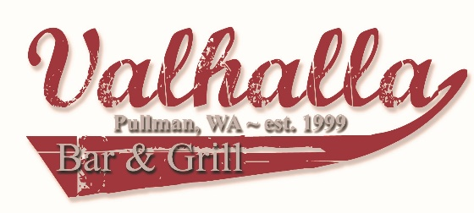
Valhalla Mug Club
Valhalla Mug Club members are a select group of loyal customers who deserve a little appreciation with their drink order. Any drink or beer ordered in a mug will be a larger amount costing the same as a double or pint glass. There are often special opportunities only available to Mug Club members, such as exclusive “Mug Club Member” t-shirts, included upon approval. Mugs are kept on site but can be taken with you at any time. All applications must include a picture of the applicant and a check made out to Valhalla Bar and Grill in the amount of $75.00. It is also required that applicants must “like” Valhalla Bar and Grill on Facebook and show proof at time of submitting application. If any of the aforementioned requirements are not met, the application will be declined. If you are not selected your checks will be available for pick-up at Valhalla after the list of new members is posted. Thank you for applying and we wish you the best of luck!
Name: _____________________________
Please check one of the following:
- Choose your own nickname:______________________________
*No more than 12 characters including spaces*
- Allow Valhalla Staff to choose your nickname
Shirt size: S M L XL 2XL
Please answer the following questions on the back:
1.) Name all the Valhalla staff members you know.
2.) Who is your favorite staff member and why?
3.) If you could have your own drink featured at Valhalla, what would it be and what would you name it?
4.) What is your favorite menu item?
5.) If you could add something to the menu, what would it be?
6.) What does “C.A.T.” stand for in C.A.T. Hour?
7.) What’s your most memorable experience or embarrassing moment at Valhalla or due to being at Valhalla? Don’t be shy! ;)
8.) Why do you feel you should be accepted into the Valhalla Mug Club?
GOOD LUCK!
1.)

2.)

3.)

4.)

5.)

6.)

7.)

8.)

